CHAPTER THREE
3.0 METHODOLOGY
There are maany machine Learning Schemes, such as Random Forest (RF), Support Vector Regression (SVR), Partial Least Squares Regression (PLSR) and Artificial Neural Networks (ANNs), that can be applied to recognition of the types, amounts, and nutritional content of food. Among them, the ANN-based approaches have an advantage wherein nonlinear relationships between the input (multispectral images) and the output (target values) can be taken into consideration in constructing the estimation rules. This leads to higher performance in terms of classification and regression. Accordingly, a supervised learning approach that employs convolutional neural networks (CNNs) was adopted in this study.
This chapter describes the methodology adopted in the development of the project. A supervised learning approach using Convolutional Neural Networks (CNN) was employed for the classification of food items. Among various machine learning techniques such as Random Forest, Support Vector Regression, and Artificial Neural Networks, CNN was selected due to its superior performance in image classification tasks (Krizhevsky et al., 2012; He et al., 2016).
3.1 Method of Data Collection
This study adopted secondary data as the primary source for model development.
The main dataset was obtained from Kaggle, an open-source data repository. The Food-101 dataset was used as the primary dataset. It can be downloaded from the following link:
KaggleLink: https://www.kaggle.com/datasets/dansbecker/food-101
This dataset contains 101 food categories with thousands of images, making it suitable for training Convolutional Neural Networks (CNN).
To improve the model’s relevance to the Nigerian context, the researcher also collected primary data by capturing additional images of popular local dishes such as jollof rice, egusi soup, pounded yam, amala, eba, and moi moi using a smartphone camera under different lighting conditions and angles.
The combination of the Food-101 dataset and custom Nigerian food images helped enhance the model’s accuracy and practical usefulness for dietary monitoring in Nigeria.
3.2 Data Preprocessing
The collected images were preprocessed to improve model performance. All images were resized to 224 × 224 pixels. Data augmentation techniques such as rotation (0.2), width and height shift (0.2), shear (0.2), zoom (0.2), and horizontal flip were applied to increase the diversity and size of the dataset. The dataset was split into training (75%) and testing (25%) sets.
3.3Overview of the System Design
This model focuses on the existing method that is created utilizing some deep learning methods. These existing techniques were carried out using ResNet51, which is one of the transfer learning methods, however it does not achieve great accuracy.
This classification of food items for dietary monitoring model is developed using Convolution Neural Network (CNN) of deep learning together with the Transfer learning approaches, as image analysis-based ways for detecting nutritional insufficiency.
For the consecutive simulation of this model, the Python scripting language was employed, with a system configuration of 8 GB RAM, Intel i5 processor, and Windows 11 operating system. Model evaluation with a large number of saved models and the ability to load and evaluate the models with the maximum accuracy and minimal loss.
Additionally, the graph accuracy among the 12 classes of food was obtained. There 12 classes considered, contain 709 images for training and 124 images for testing. This study also benefits people who are on the journey to loose or gain weight and suggests a healthy lifestyle by recommending the food that they can consume.
This system consist of two modules namely user and system modules, and each module has its own functions. The user of this system can perform the following operations:
- Upload Image: The user has to upload an image which needs to be classified.
- View Results: The classified image results are viewed by user.

3.4 Input Design
Input design implies detailed descriptions of the data essential for the establishment of the new system to run effectively. This is related to the field of study, it includes email address and password.

CLASSIFICATION OF FOOD ITEMS FOR DIETARY MONITORING
Browse Image or Drag an Image here
Submit

Figure 3.1 Input Design

3.5 Output Design
Output analysis guides the format of newly established system, displaying the names and other information about the numerous students, staffs and possible responses the computer could produce when it encounters an authorized conclusion e.g. keying in using wrong data etc.

FISH AND CHEEPS

PREDICTION ACCURACY: 99.8%
Figure 3.2 Output Design

Figure 3.2 Output Design

3.6 File Design
3.6.1 Use Case Diagram
Use-case diagrams describe the high-level functions and scope of a system. This diagram also identify the interactions between the system and its actors. The use case diagram in Figure 3.4 below describes the actions that can be performed by the user of the system.

User

Log in
View Results

Upload Image

Figure 3.3 Use Case Diagram

3.6.2 System Flowchart
A flowchart is a diagram that represents a workflow or process. A flowchart can also be defined as a diagrammatic representation of an algorithm, a step-by-step approach to solving a task. The system flowchart despise the flow of operations performed by the users of the system. Figure 3.4 shows the program flow chart used for the development of the system.

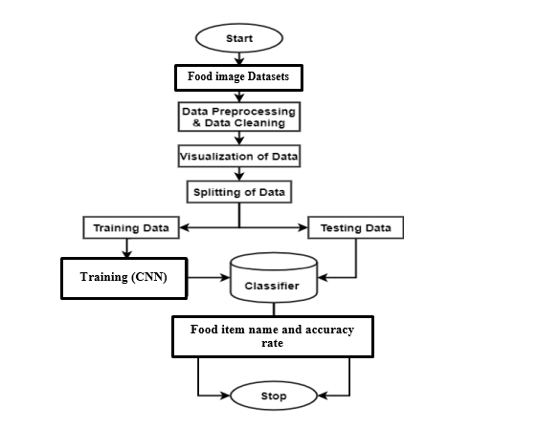
Figure 3.4 System Flowchart

3.6.3 System Architecture
The systems architecture process is where the concepts that will be the backbone of the actual system are developed. System architecture is the conceptual model that defines the structure, behavior, and more views of a system. An architecture description is a formal description and representation of a system, organized in a way that supports reasoning about the structures and behaviors of the system.
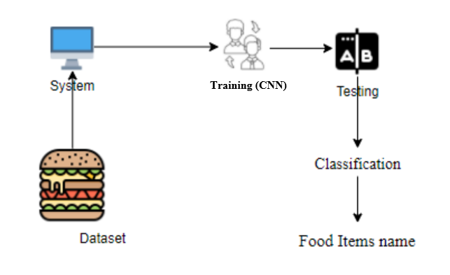
Figure 3.5. The System Architecture
Above architecture diagram shows three stages of data flow form one module to another module. Data collection, preprocessing, and algorithm training.

